Basic Rules
These rules are a simplified version of those found in the full rulebook. You can use these in place of those rules, or as a useful introduction to them. Or you may wish to ignore them completely.

Components
You will need:
One (1) six-sided die.
Two (2) ten-sided dice of different colors.
Two (2) sets of team cards.
A Stadium Card (e.g. Fenway Park 1986).

Setup
1. Select the starting defense and starting lineup for each team.
2. Place the starting lineups in front of you, with each team’s leadoff hitter on top. If you aren’t playing with the designated hitter rule, place a “Pitcher Batting Card” at the bottom of each lineup.
3. Stack each team’s pitchers in a separate pile, with the starting pitcher on top.
4. Set each team’s bench players to the side.

Start of Play
The game starts with the first batter in the away team’s lineup facing off against the home team’s pitcher.
To determine the result of this plate appearance, roll one of the six-sided dice and both ten-sided dice to generate a random number between 100 and 699.
For example:
DdH = 437

Play Results
The six-sided determines the location of the play result:
AB | Pitcher Card | E | Defense
CD | Batter Card | F | Stadium Card

Pitcher Cards
Rolls of 100-299 are found on the pitcher’s card. For some rolls, the outcome is determined by the batter’s handedness. On the card below, a roll of 244 is a single (1B+) if the batter is a lefty (or switch-hitter) and a strikeout (K) if the batter is a righty.
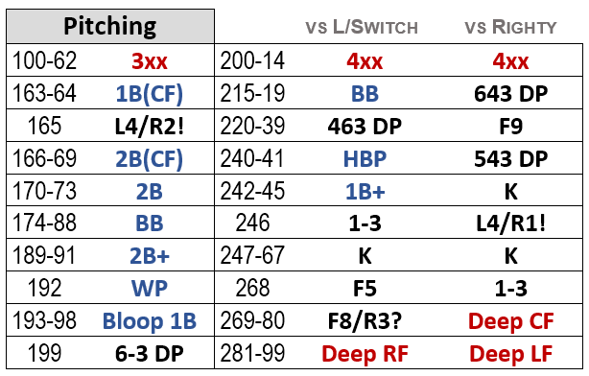

Batter Cards
Rolls of 300-499 are found on the batter’s card. As with pitcher cards, some rolls are affected by the current pitcher’s handedness.

Defense
Rolls of 510-599 are found on a defensive player’s card, with the “tens” digit specifying the position (according to the numbering system used by scorekeepers):
510-519 = Pitcher  520-529 = Catcher  530-539 = 1B  540-549 = 2B  550-559 = 3B  560-569 = SS  570-579 = LF  580-589 = CF  590-599 = RF | 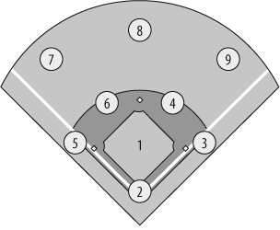

Rare Plays
In the full game, rolls of 500-509 trigger Rare Plays. In the Basic Game, ignore these rolls and roll again.

Stadium Card
Rolls of 600-699 are found on the Stadium Card.
For all rolls of 600 or higher:
- Add 10 for each level of pitcher Fatigue (page 3).
- Add 10 if the home team is batting.

Redirection
Results in red redirect to other cards:
Deep LF | Roll on Deep Drive table  on the Stadium Card
Deep CF
Deep RF

3xx | Redirect to a different roll,  keeping the last two digits the same.

Example #1:  145 redirects to 345. | 101-56 3xx

56x | Redirect to a different roll,  keeping the last digit the same.

Example #2:  277 redirects to 567. | 274-78 56x

Reading Play Results
Each result is described with the notation used by baseball scorekeepers. For example, hits use the following abbreviations:
1B(IF) | Infield Single: Runners advance 1 base
1B  1B(LF)  1B(CF)  1B(RF) | Short Single: Runners advance 1 base
2B | Double: Runners advance 2 bases
3B | Triple: All runners score
HR | Home Run: All runners score
The following variations are also possible:
1B+ | Outfield Single  Runners on 2B and 3B score.  Runner on 1B stops at 2B.
1B++ | Long Single  All runners advance 2 bases.
2B+ | Long Double  All runners score.

Bloop Hits
A “Bloop Hit” is a batted ball that hangs in the air before falling in for a hit. With less than two outs, runners must be sure the ball isn’t caught before they advance. Therefore, runner advancement on “bloop” hits is determined by the number of outs:
 | Less than 2 Outs | 2 Outs
Bloop 1B | All runners  advance 1 base. | All runners  advance 2 bases.
Bloop 2B | All runners  advance 2 bases. | All runners  advance 3 bases.

Outs
Outs also use traditional scorekeeper notation, as in the following examples:
K | Strikeout.
F9 | Fly out or line out to the right fielder.  Runners hold.
F9+ | Deep fly out to the right fielder.  With less than 2 outs, the runner on 3B tags up and scores (if applicable).
F9++ | Deep fly out. Runners on 2B and 3B  tag up and advance (if applicable).
L4 | Line out to the second baseman.
5-3 | Ground out to the third baseman  (who throws to 1B for the force out).  Runners advance 1 base.
543 DP | Ground out to third.  With a runner on 1B and less than  2 outs, this is a 5-4-3 double play.  Otherwise, change to 5-3 (above).
3-1 | Ground ball fielded by the first baseman.  1B tosses to pitcher for force out at first.
3U | Ground ball fielded by the first baseman.  1B tags first base for unassisted force out.

Other Results
BB | Walk | Runners advance  if forced
HBP | Hit Batter
E6 | 1-Base Error | Batter safe at first  Runners advance 1 base
E6 (2) | 2-Base Error | Batter safe at second  Runners advance 2 bases
PB | Passed Ball | Runners advance 1 base  (Re-roll if bases empty)
WP | Wild Pitch

Interpreting Ground Out Results
Ground out results show the best possible defensive outcome, assuming the force play is in effect. For example, 643iDP refers to a “tailor-made” double play ball — but a double play can only occur with a runner on first and less than two outs. If a result is impossible, adjust the result to match the game situation: 643iDP or 6-4 with no runner on first becomes a 6-3 ground out.

Runner Advancement on Outs
Runners do not advance on line outs or fly outs (unless noted, e.g. F9+). On ground outs, runners advance one base.

Runner Events
Additional runner events are denoted after a slash (e.g. L6/R2!). In the Basic Game, ignore notations after a slash.

Pitcher Fatigue
Each team’s pitcher has a Fatigue level — a number that starts at zero when a pitcher enters the game. This number increases as the pitcher becomes tired.
The pitcher’s Stamina specifies the number of innings in which a pitcher can pitch without his Fatigue level rising above zero.
After exceeding their Stamina, a pitcher becomes vulnerable to fatigue. From this point on, each baserunner allowed increases Fatigue by one (1).
(A baserunner is defined as a hit, walk or hit batter.)
A pitcher with a Stamina of ‘0’ is vulnerable to Fatigue from the first batter they face.
Stamina refers to the number of actual innings in which the pitcher pitches. There is no need to track the number of batters faced or outs recorded.
Example: Rick Honeycutt (1988) enters the game with two outs in the 7th inning. When he begins the 8th, this is inning #2 (his second inning). This exceeds his stamina rating of 1, meaning that he is now vulnerable to fatigue.

Effect of Fatigue
For rolls of 600-699, add 10 for each level of Fatigue.
Rolls below 600 are not affected by Fatigue.

Stamina Ratings
If a player has two Stamina ratings listed (e.g. 5/1) use the first rating when they are used as a starter and the second rating when they are used as a reliever.

Steal Attempts (Basic Game)
To steal a base, roll all three dice and add them together. Add this total to the base stealer’s Speed rating. If this equals or exceeds the number listed, the runner is safe. Otherwise, the runner is out.
Steal 2nd | Steal 3rd | Steal Home
16 | 16 | 22

Sacrifice Bunts (Basic Game)
With a runner on first, the offense may attempt a Sacrifice Bunt. Roll all three dice, add the player’s Bunt rating, and find the total on the following table:
 |  | U+ u+ U + Bunt rating
Total
1-7 | 163 DP |  | Bad bunt in front of home plate.  Ground ball double play.
8 | 263 DP
9-12 | K |  | Batter strikes out.
13 | 3-6 |  | Runner is forced out at 2nd base.  Batter is safe at first.
14 | 5-4
15-23 | SAC  (1-3) |  | Batter is out.  All runners advance 1 base.
24+ | 1B(IF) |  | Batter is safe with an infield hit.  All runners advance 1 base.

Games like Dungeons & Dragons® use the 10-sided die to generate a number between 1 and 10 — if you roll a ‘0’, you interpret it as ‘10’. Season Ticket Baseball does not do this. A zero is always a zero.

Additional Options
The Season Ticket Baseball rulebook includes rules for the following topics:
- Runner Advancement on Hits
- Hit and Run / Hitting to the Right Side
- Squeeze Plays
- Bringing the Infield In
- Weather and Injuries
- Rare Plays
- and much more…

